BIG BLUE BIRD ORDER FORM

Thank you for buying the Big Blue Bird calendar. Many of the Big Blue Bird images are available as notecards or postcards. You may use this form to order cards or additional calendars. You can see more art at www.lezbag.com. Again, thanks for your support. Leslie

NOTECARDS | Name |  |  | Price | Qty |  | Cost
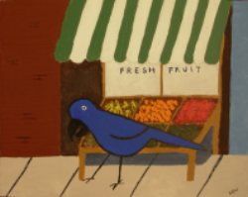 | At the Green Grocer |  |  | 3.00
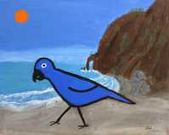 | Bird at Neahkahnie |  |  | 3.00
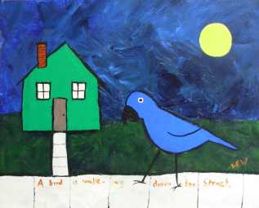 | A Bird is Walking Down the Street |  |  | 3.00
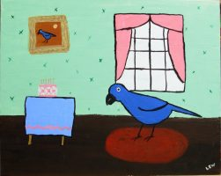 | Birthday Bird |  |  | 3.00
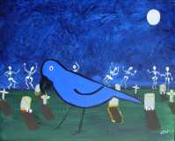 | Cemetery Bird |  |  | 3.00
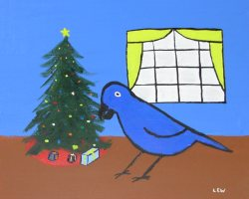 | Christmas Bird |  |  | 3.00
 | Day of the Dead Shrine |  |  | 3.00
 | Library Bird |  |  | 3.00
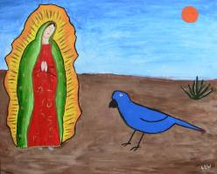 | Our Bird of Guadalupe |  |  | 3.00
 | Sleeping Gypsy with Bird |  |  | 3.00
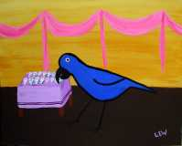 | Sugar Skulls |  |  | 3.00
Subtotal this page
Notecards | Name |  |  | Price | Qty |  | Cost
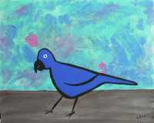 | Turquoise Bird |  |  | 3.00
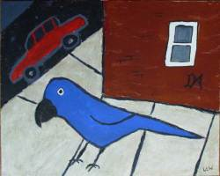 | Urban Bird |  |  | 3.00

POSTCARDS
 | Birthday Bird |  |  | 1.00
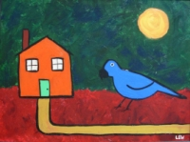 | Bird and House |  |  | 1.00
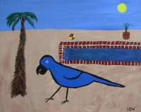 | By the Pool |  |  | 1.00
 | Our Bird of Guadalupe |  |  | 1.00
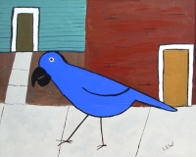 | Street Bird |  |  | 1.00
 | Postcard 5-pack (one of each) |  |  | 4.00
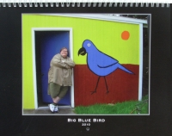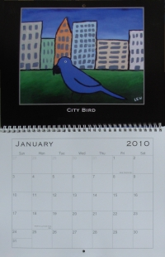 |  |  | 2010 Calendar | 20.00
Shipping  $1-10: $1.00  $10-25: $2.00  $25-60: $5.00  over $60: I’ll contact you |  | Subtotal this page
 |  | Subtotal previous page
 |  | SHIPPING
 |  | GRAND TOTAL

Date Return this form to: Leslie Waygren

11412 NE Siskiyou St.

Name Portland, OR 97220

This form is also available at www.lezbag.com

Address as a Word document which you can download,

fill out, and send as an email attachment to me at

lezbag@yahoo.com

THANKS FOR YOUR ORDER! www.lezbag.com

